
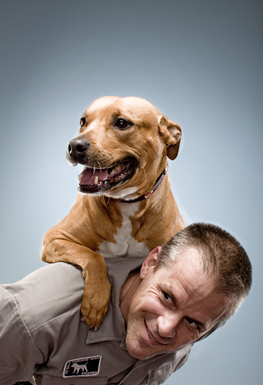

Jeff Jenkins

Lead trainer
End Dogfighting campaign’s
Pit Bull Training Team

A native of Chicago, Jeff Jenkins joined The Humane Society of the United States’ End Dogfighting Campaign to help found the Pit Bull Training Team. He believed that this program needed to address the street dogfighting problem on both ends of the leash. The dogs needed to be socialized, trained, and cared for in a safe, humane and realistic manner. And the owners of these animals needed to be educated and inspired to change the way they think, feel, and ultimately raise and relate to their dogs.

Jeff came to the world of dog training and animal welfare in a rather unorthodox manner. When he was eighteen he joined the circus. He spent many years traveling the globe as an acrobat and a clown. During this time he witnessed some remarkable human and animal relationships based on trust, compassion, and respect. He also witnessed many others that were not.

Upon returning to Chicago he spent several years working alongside and learning from many of the cities finest dog trainers. Jeff took this training coupled with his previous experiences and developed his own style of dog training based on the principles, of being firm, fair, and overwhelmingly positive. He gained a reputation in Chicago for doing remarkable work particularly with very challenging dogs.

Jeff rescued Lola, his first pit bull on Chicago’s west side nearly ten years ago. He knew she was the dog for him when he threw a ball and she raced off after it, returned quickly and just as Jeff reached down for the ball she bit him. Since that introduction, Jeff, Lola and his latest rescued Pit Bull Junebug have traveled nationally and internationally giving performances, workshops, and seminars in various settings ranging from correctional facilities, to public schools, to Chicago Bulls games — where Lola & Junebug, can be seen entertaining 20,000 people on a regular basis.

Of all of his accomplishments the one he is most proud of is his family, Julie his wife and his two incredible kids Maxwell and Samantha.

Jeff is a firm believer in practicing what you preach. That is why he is taking the Pit Bull Training Team into some of Chicago’s most notorious neighborhoods known for dogfighting. By challenging the owners and their dogs, and giving them the tools to succeed, Jeff Jenkins and the Pit Bull Training Team are having a powerful and immediate impact on the scourge of street dogfighting.

