About the Author
Sheryl Matthys, The Dog Expert
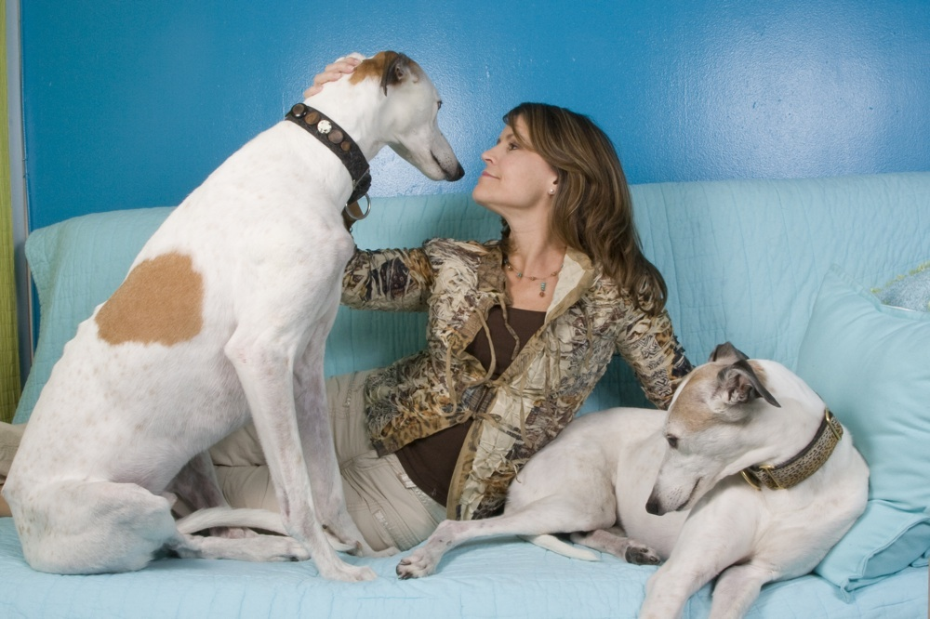
Sheryl Matthys is The Dog Expert®, who specializes in helping dog lovers with relationships by asking, “What Would My Dog Do?”
She is the Founder of Leashes and Lovers® – an online social community for dog lovers, where you can establish friendships, relationships, or browse a pet-friendly business directory to improve your dog’s life.
Sheryl believes that you can discover the secrets of success and happiness for great love, life, and work with the help of your dog. As The Dog Expert, Sheryl’s interviewed hundreds of dog lovers at her events, in dog runs and numerous celebrities like Cesar Millan, Howard Stern, and Rachael Ray about how their dogs impact their relationships.
She discovered that dogs can show humans how to rekindle flagging relationships. By asking ourselves “What Would My Dog Do” we can apply some of our dogs’ traits to our human interactions, and resolve many of the conflicts that rob our lives of joy. With plenty of information, Sheryl decided it would make for a great book and Leashes and Lovers: What Your Dog Can Teach You about Love, Life, and Happiness was born.
Leashes and Lovers released in 2010 and achieved Best Seller status on Amazon with #1 in Friendship, #3 in Dogs - just 2 under Cesar Millan, #1 in Hot New Releases in Dogs, #1 Hot New Releases in Friendship, and # 4 Hot New Releases in Relationships.
Sheryl brings a unique blend of experience to her insights. She and Shiraz were the feature story on Dog’s 101 recently for the Greyhound Breed. She’s a columnist for FIDO FRIENDLY magazine, an expert on All Paws Talk Radio, a professional speaker, author, commercial actress, entrepreneur, TV/Radio reporter & host, Greyhound rescuer, and certified dog trainer.
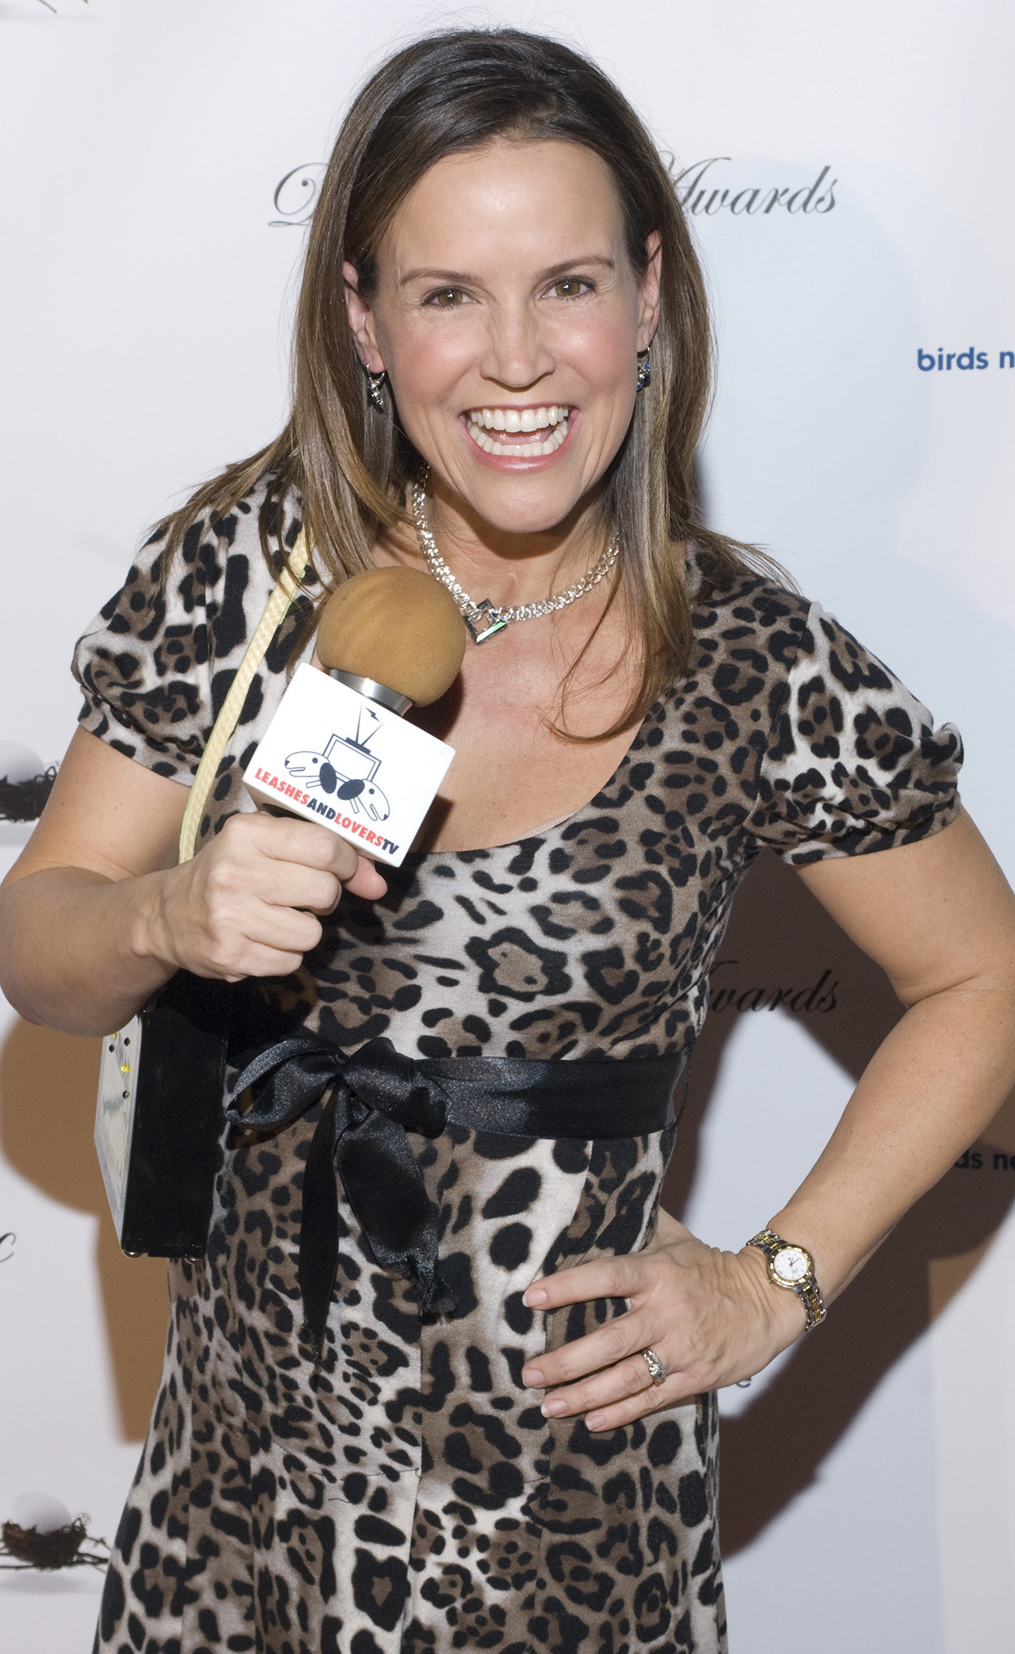
Sheryl & Leashes and Lovers have been featured on ABC NEWS NOW, Animal Planet, E!, FOX News Channel, Sirius-XM, The New York Times, USA Today, Entrepreneur Magazine, Ambush Makeover, Bravo, Modern Dog Magazine, as well as hundreds of other newspapers, websites, magazines, and TV/radio stations around the country and the world.

